To run the API from Visual Studio 2019, do the following

1. Restore the packages used in the project
2. Update the connection string under appsettings.json file

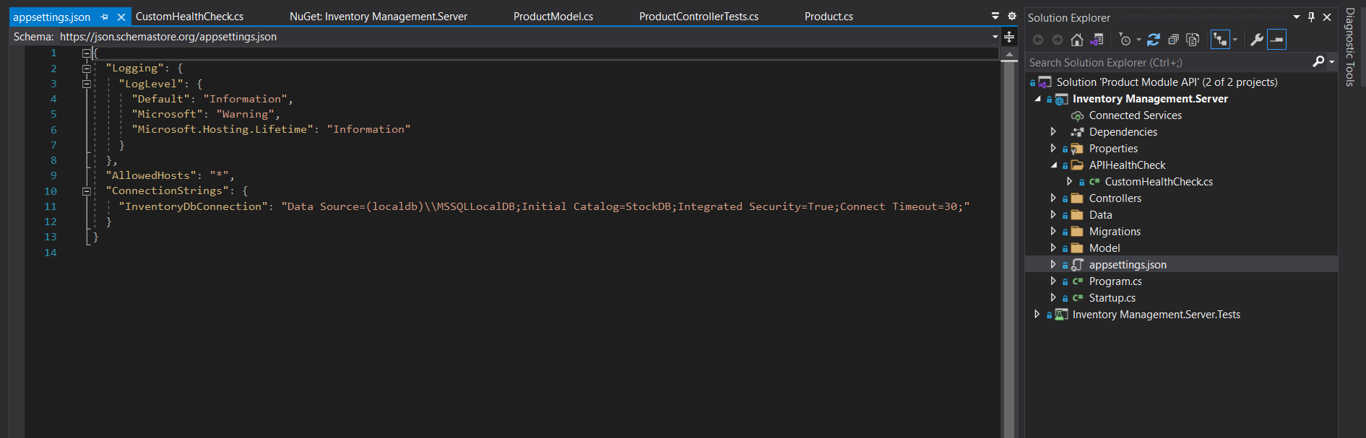

* (You can run with same connection string if you have default sql server object viewer of Visual studio unmodified)

1. Open package manager console (Tools->Nuget Package manager->PackageManagerConsole)

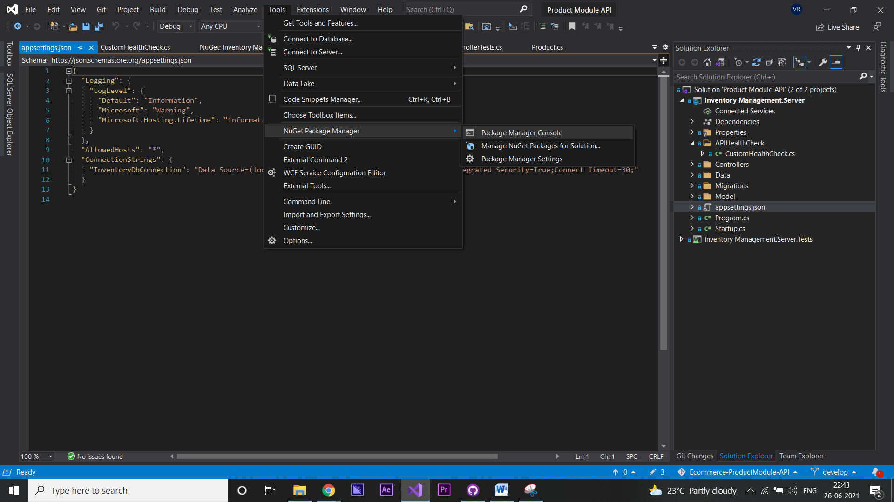

1. Run **Update-DataBase** command (This will create the DB and Tables as per migration available )
2. Press Ctrl+f5 or Debug-> Start without debugging
3. Below openAPI specification document webpage starts and You can use the in-built tools of the swagger to verify data or use any tools like postman to communicate with API

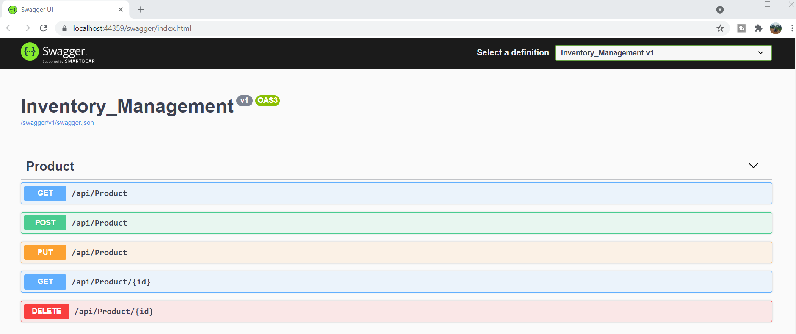

Time Tracking :

* Data Store design : 1 hour(Using Entity Framework core Code first Approach)
* API and service logic : 1 hour (.net 5 and Custom API health check)
* Unit Testing : 2.5 hours(Xunit and Moq)